|  |
| --- |
| College LaSalle |
| Project - Internet Programming User Manual |
|  |
| Presented to: Mihai Maftei |

|  |
| --- |
| Author: Gabriel Paz Paiva  7/20/2021 |

1. Enter your Username and Password and then press login to access my web site. (**Gabriel@proj.ca**, **123**)
2. If you want to clean the username and password text boxes, you may press “Reset” button.

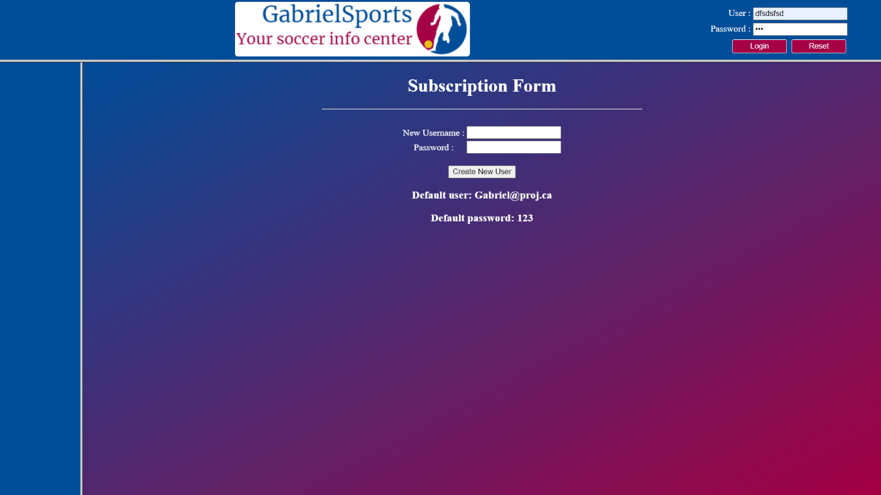

1. If you enter the wrong login or password, you will be redirected to this page inviting you to subscribe to create a new user. Since there is no connection with the server, the login and username are displayed in the content.

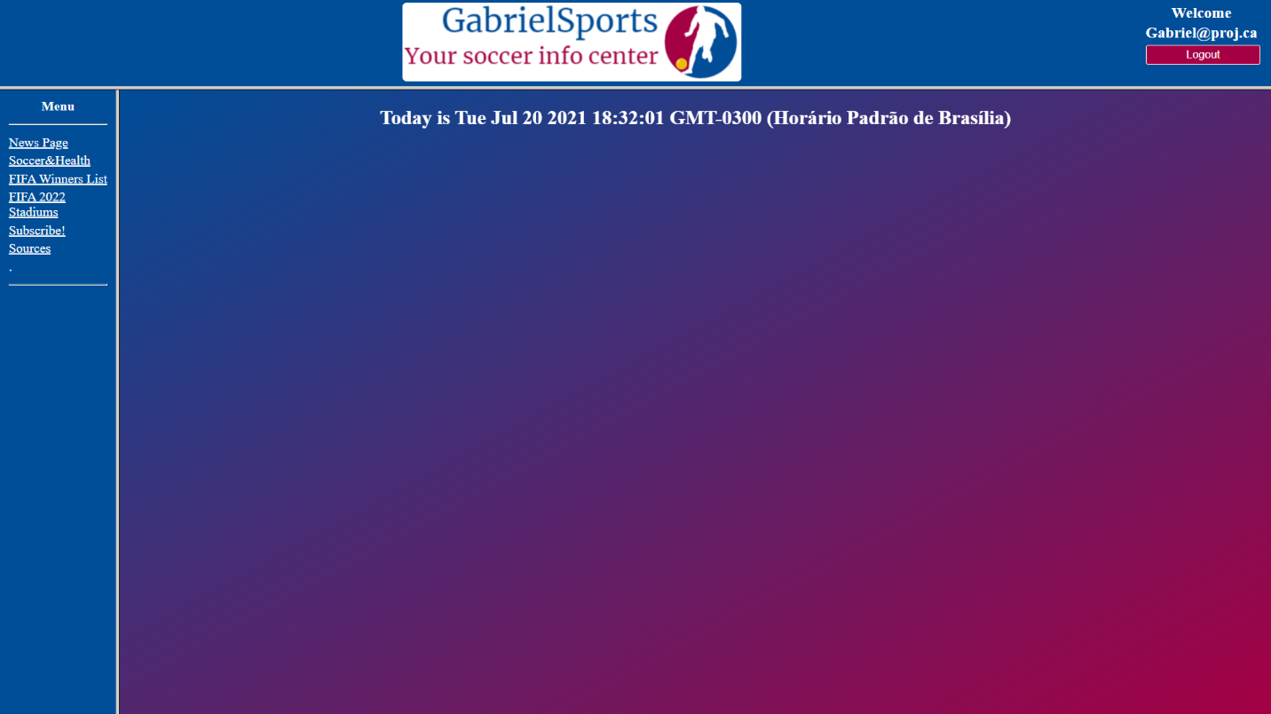

1. This is the Main Page. From now on you always have the option to come back to this page by clicking in the “GabrielSports” logo at the top of the page.
2. Also, a “logout” button is always displayed at the top right corner. If you want to logout or comeback to the first image, you should press it.
3. At the left side of the screen, you may see all the pages to go. If you want to access one of them, just click in the name.
4. The page will always display the current time at the center of the content page.

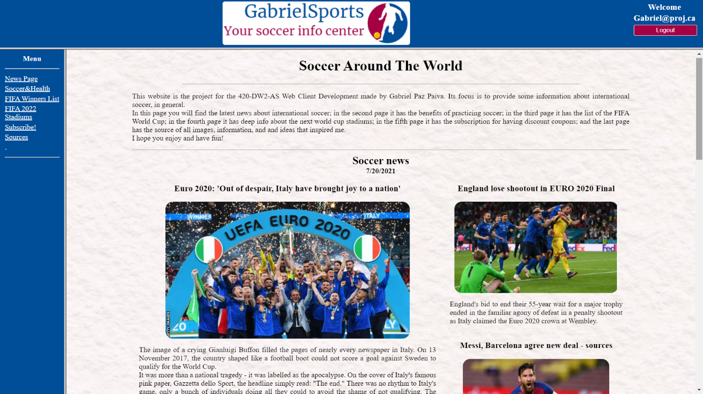

1. After pressing “News Page” on the menu options you will be redirected to this page. Here you can check some of the latest news of international soccer.
2. Some headlines are displayed, but you also have the option to click in one of the images and then you will be redirected to the specific news page to check the whole content.
3. At the end of the page there are two buttons. If you want to get back to the top of the page, you may press “Go to the top”. If you want to get back to the main page, you may press “Go to the Menu”.

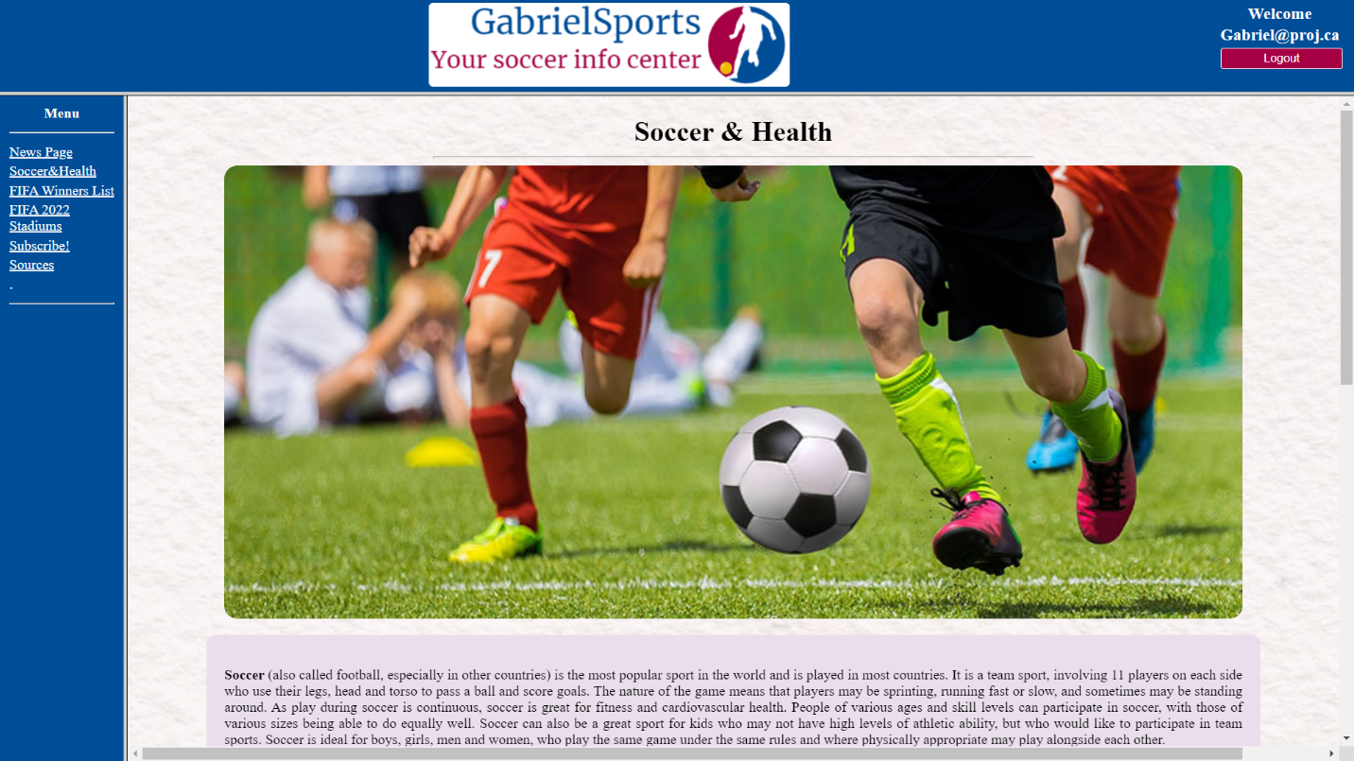

1. After pressing “Soccer & Health” on the menu options you will be redirected to this page. Here you can check some information about the benefits of playing soccer.
2. At the end of the page there are two buttons. If you want to get back to the top of the page, you may press “Go to the top”. If you want to get back to the main page, you may press “Go to the Menu”.

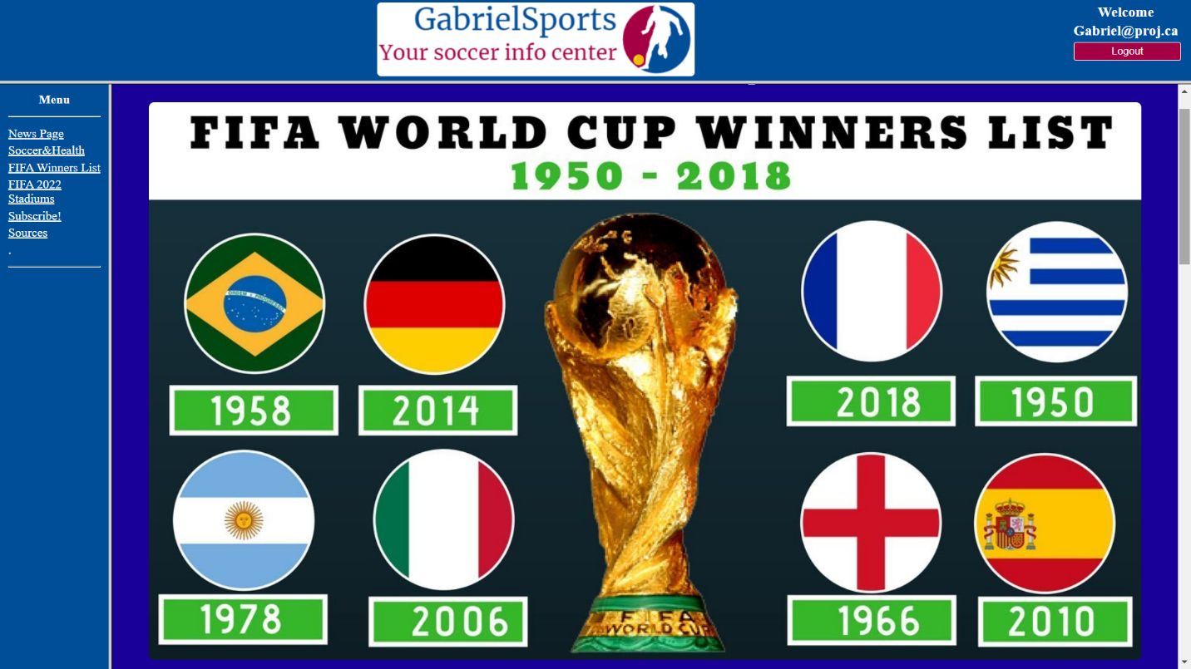

1. After pressing “FIFA Winners list” on the menu options you will be redirected to this page. Here you can check all the FIFA World Cup champions of all time.
2. If you want to have some information about a specific country, you may press the flag and you will be redirected to the information related to that one.
3. If you want to go back to the top, then you may click in “go to the top”.

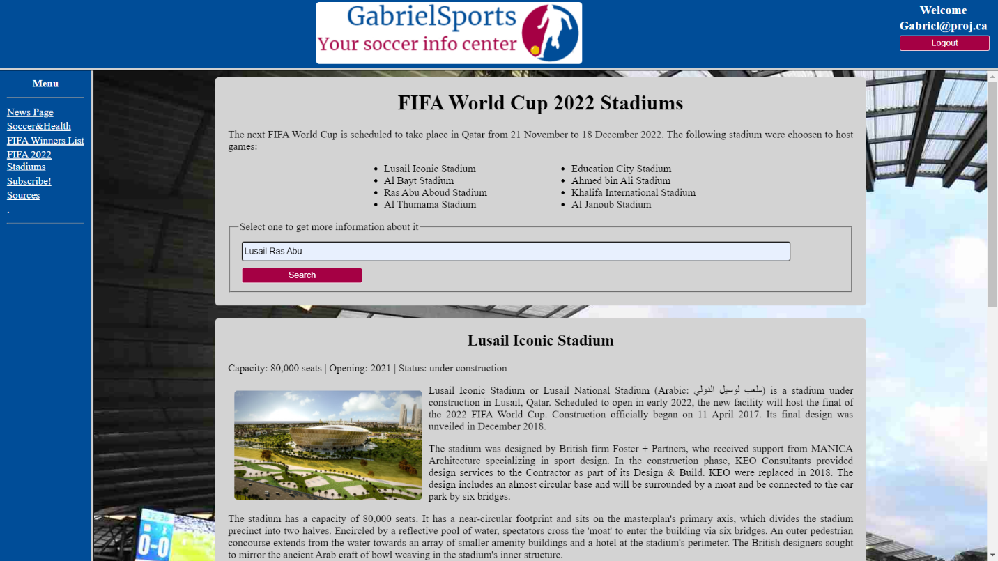

1. After pressing “FIFA 2022 Stadiums” on the menu options you will be redirected to this page. Here you can check some information about all the stadiums of the next World Cup.
2. There is a list with the names of the stadiums, if you want to know about one, two, or either all of them, you should write it in the text box and press “Search” button. You do not need to worry with Uppercase or Lowercase letters.
3. At the end of the page there are two buttons. If you want to get back to the top of the page, you may press “Go to the top”. If you want to get back to the main page, you may press “Go to the Menu”.

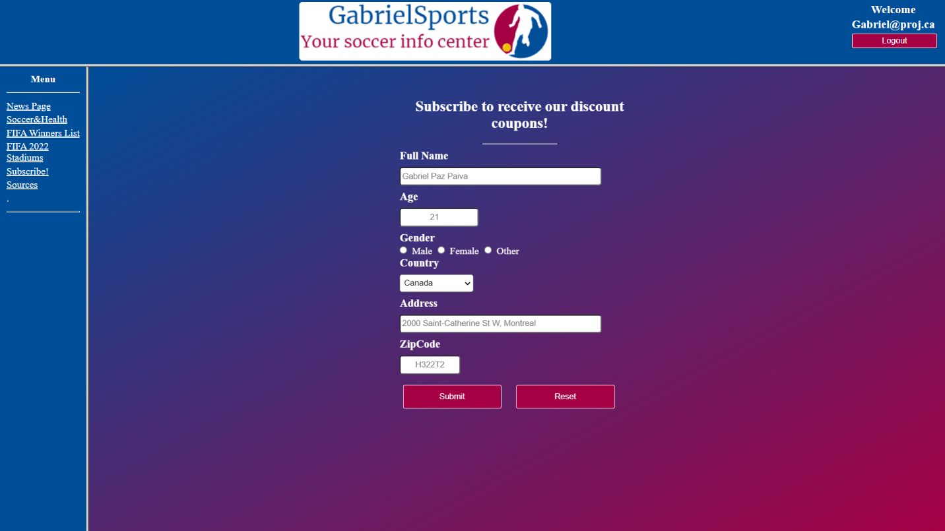

1. After pressing “Subscribe!” on the menu options you will be redirected to this page. Here you can subscribe to receive some discount coupons.
2. To complete the form, you should fill all the forms. The first textbox does not accept numbers as entries. The second textbox only accepts numbers until a certain value. Lastly, the zip code box only accepts a specific format. If there is any problem, the system will notify you about the issue.
3. When you finish, you may press “Submit” button or “Reset”, if you want to clear all the form and start over.

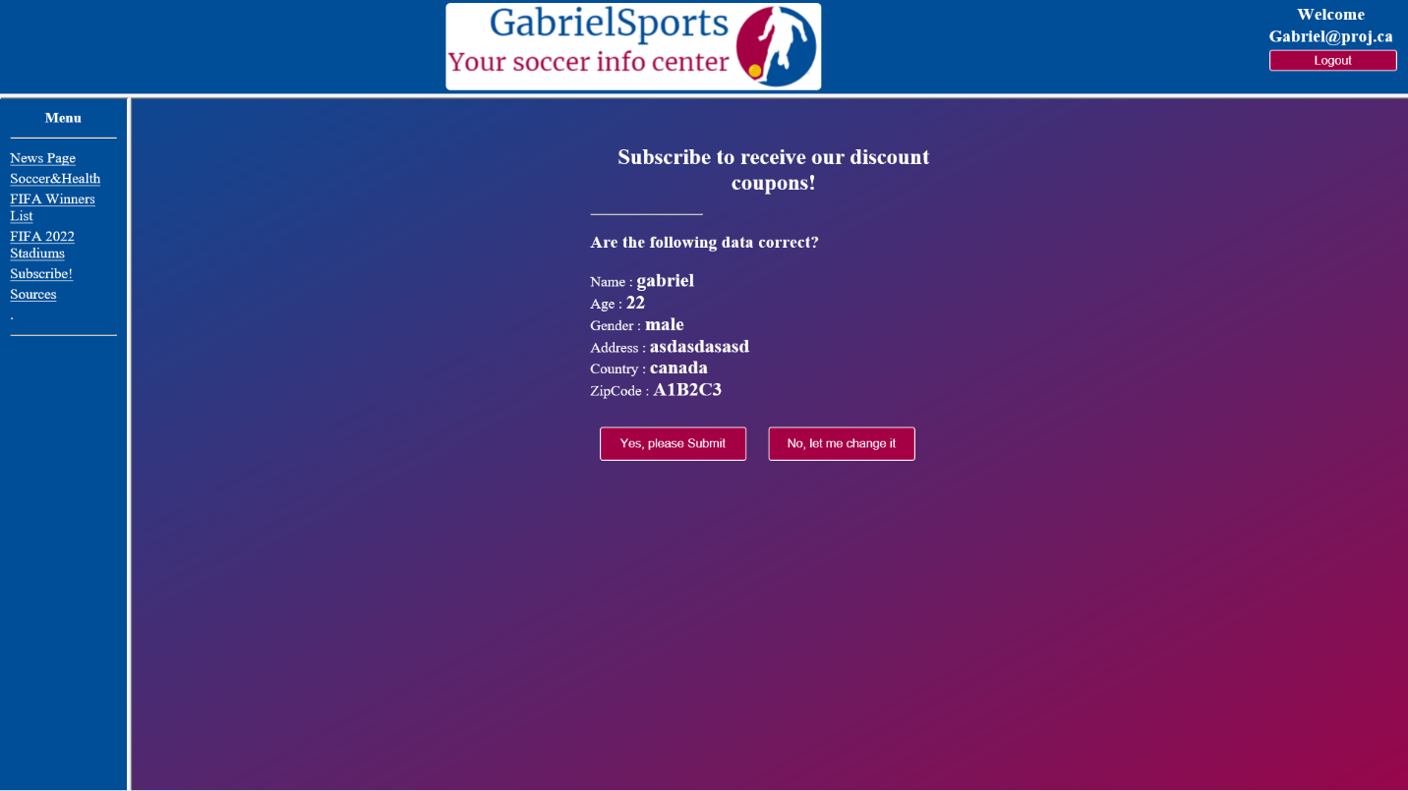

1. After pressing “Submit” button in the last page, you will be redirected to this page where you should confirm or deny the information displayed.
2. If something is not right, then you should press “No, let me change it” button, otherwise you should continue the submission by pressing “Yes, please Submit” button.

1. After pressing “Yes, please Submit” button in the last page, you will be redirected to this page where you can verify the time you took to fill the form.
2. If you want to get back to the main page, you may press “Go to the Menu”.

1. After pressing “Sources” on the menu options, you will be redirected to this page. Here you can check a list of all the links of contents and inspiration I used to complete this webpage.